Feng Chia University

Electrical Engineering Fundamentals II Lab

Laboratory 3

AC RL Circuits and Phasor

Instructor: Prof. Shyan-Lung Lin

Student Name: 周嘉禾

Student ID: D1166506

Experiment Date:14/03/2023

1. Introduction
2. To observe the RL Circuits and Phasor under Alternative Current
3. Materials
   1. Waveform Generator
   2. Digital Oscilloscope
   3. Digital Multimeter
   4. Devices

Resistors: R = 1 Ω, 10 Ω, 100 Ω, 1kΩ

Inductor: L = 1 mH

1. Circuit diagram

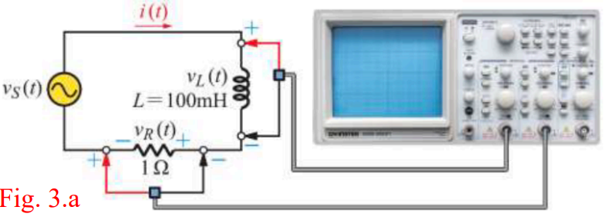

▲ Figure 1. Circuit of Experiment 3.a Pure Inductive AC Circuit

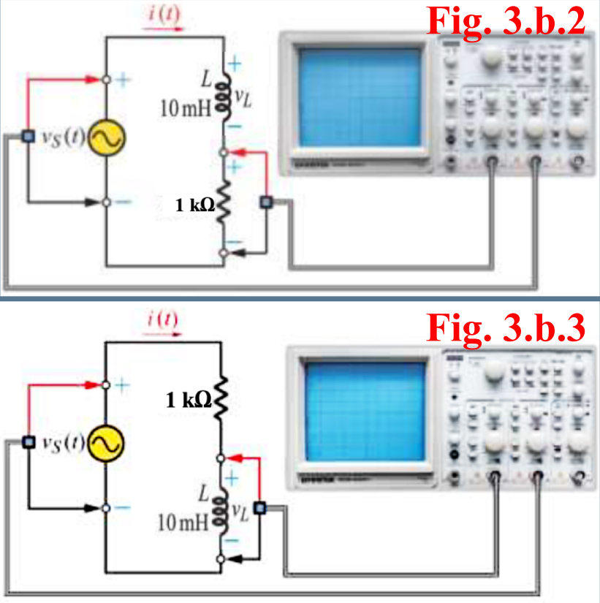

▲ Figure 2. Circuit of Experiment 3.b RL Series Circuit

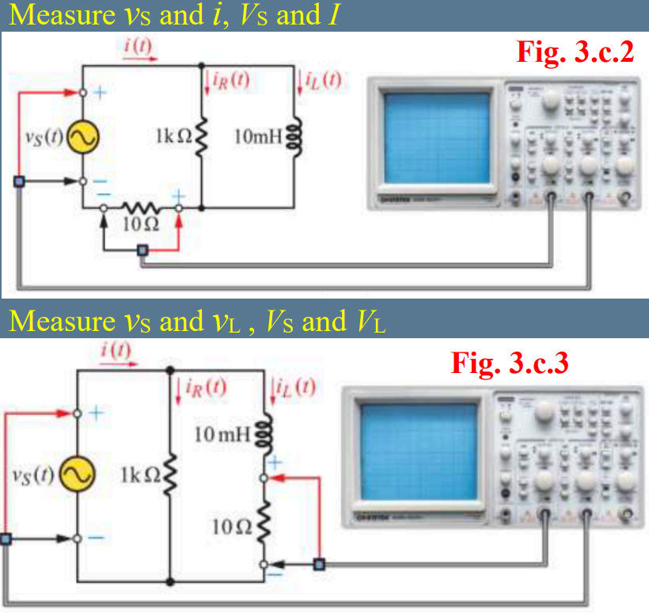

▲ Figure 3. Circuit of Experiment 3.c RL Parallel Circuit

1. Methods

Using Digital Multimeter to observe current and voltage and Oscilloscope to observe the wave.

1. Experiments data
   1. Experiment 3.a Pure Inductive AC Circuit

Table 1: Measurement of Pure Inductive AC Circuit

|  |  |  |  |  |
| --- | --- | --- | --- | --- |
| f | XL | I | | θ |
| Theoretical | Measurement |
| 100 Hz | 62.8319 Ω | 0.0796 A | 0.0090 A | 9.65° |
| 500 Hz | 314.1593 Ω | 0.0159 A | 0.0067 A | 45.98° |
| 1 kHz | 628.3185 Ω | 0.0080 A | 0.0046 A | 65.05° |
| 10 kHz | 6283.1853 Ω | 0.0008 A | 0.0018 A | 80.14° |

* 1. Experiment 3.b RL Series Circuit

Table 2: Measurement of RL Series Circuit

|  |  |  |  |  |
| --- | --- | --- | --- | --- |
|  | VS | VR | VL | I |
| Theoretical | 2 V | 1.98 V | 0.198 V | 1.98 mA |
| Measurement | 1.9203 V | 1.9201 V | 543 μV | 1.839 mA |

|  |  |  |  |
| --- | --- | --- | --- |
|  | XL | Z | I leads VS by |
| Theoretical | 99.9 Ω | 1004 Ω | lags 5.7° |
| Measurement | 0.2952 Ω | 1043.9817 Ω | lags 73.71° |

* 1. Experiment 3.c RL Parallel Circuit

Table 3: Measurement of RL Parallel Circuit

|  |  |  |  |  |
| --- | --- | --- | --- | --- |
|  | VS | XL | Z | I leads VS by |
| Theoretical | 2.8 V | 99.9 Ω | 99.4 Ω | lags 84° |
| Measurement | 2.24 V | 99.7284 Ω | 66.2820 Ω | lags 111.8° |

|  |  |  |  |
| --- | --- | --- | --- |
|  | I | IR | IL |
| Theoretical | 0.028 A | 2.8 A | 0.028 A |
| Measurement | 0.0338 A | 0.0113 A | 0.0225 A |

1. Results

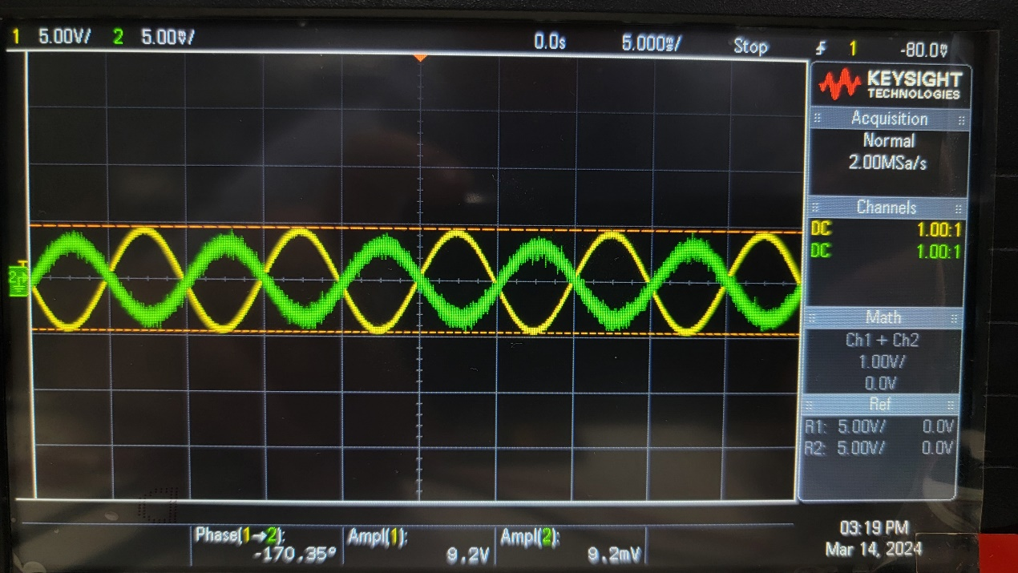

▲ Figure 4. Results of Experiment 3.a 100 Hz

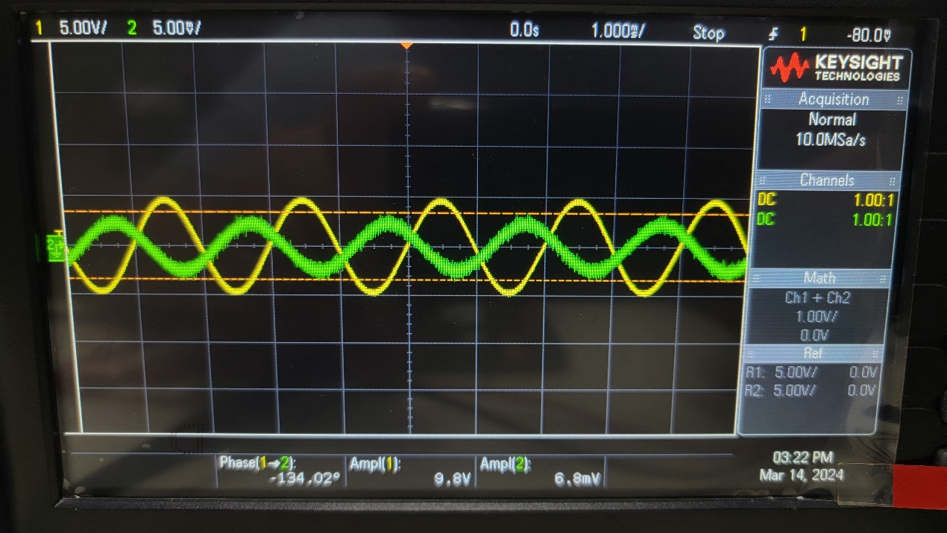

▲ Figure 5. Results of Experiment 3.a 500 Hz

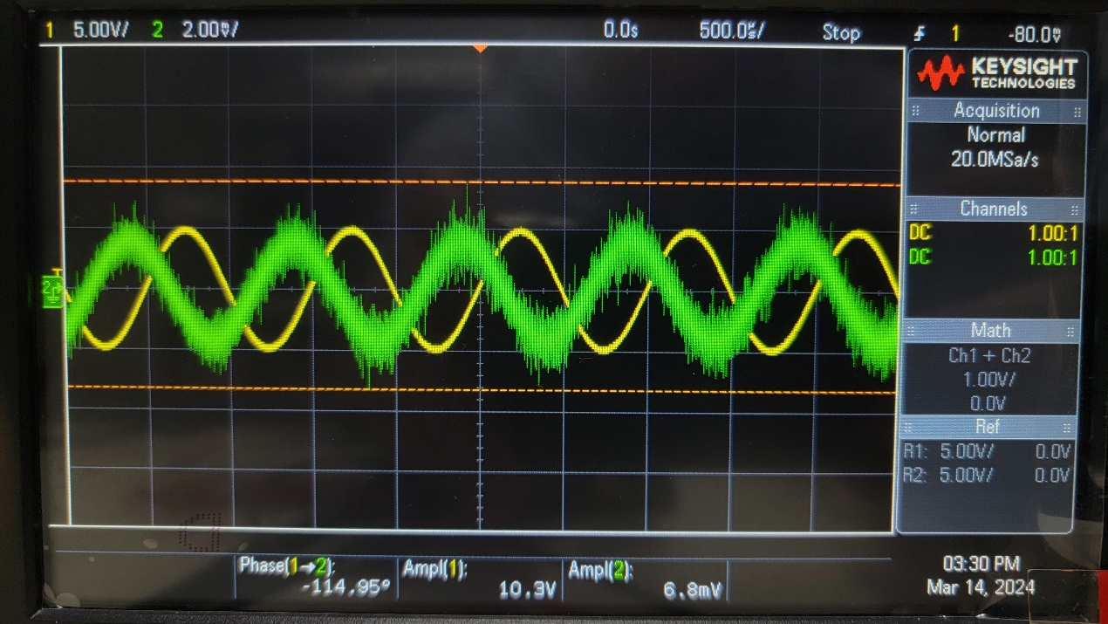

▲ Figure 6. Results of Experiment 3.a 1 kHz

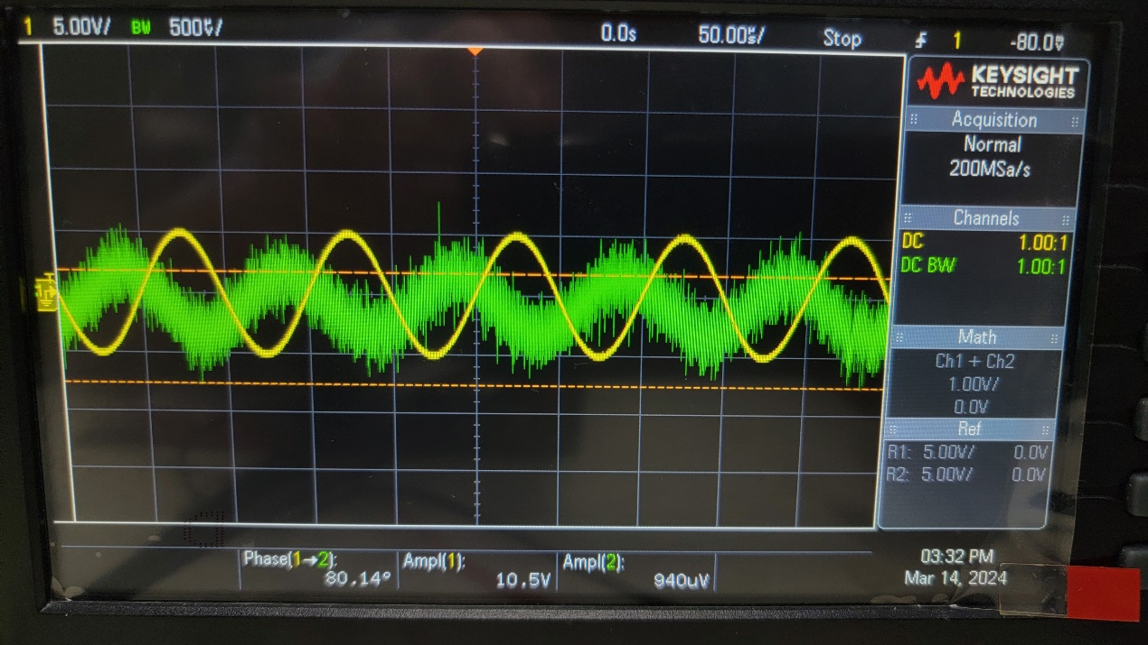

▲ Figure 7. Results of Experiment 3.a 10 kHz

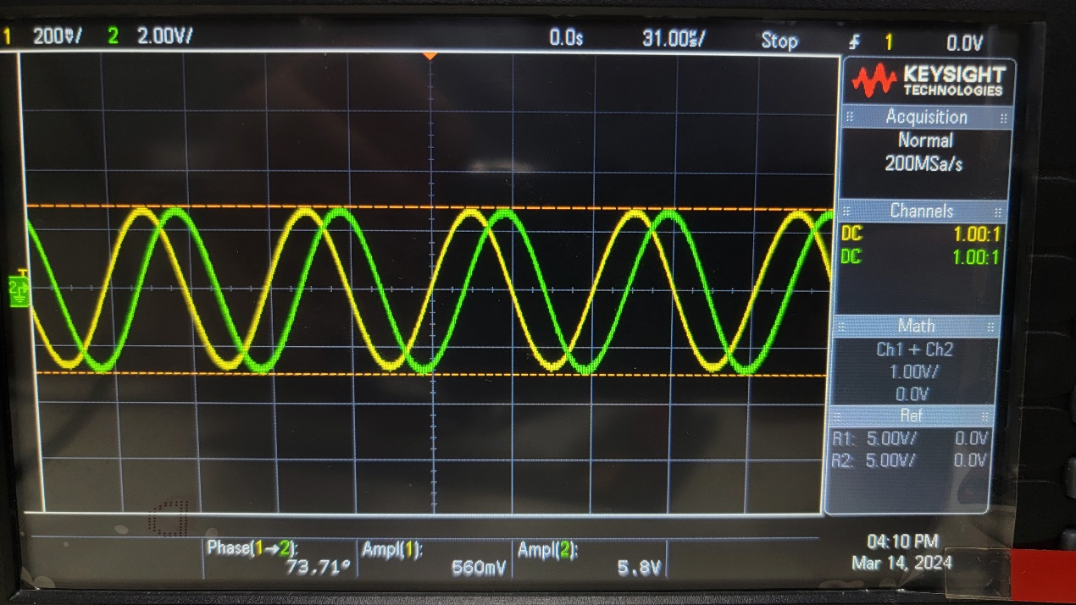

▲ Figure 8. Results of Experiment 3.b.2

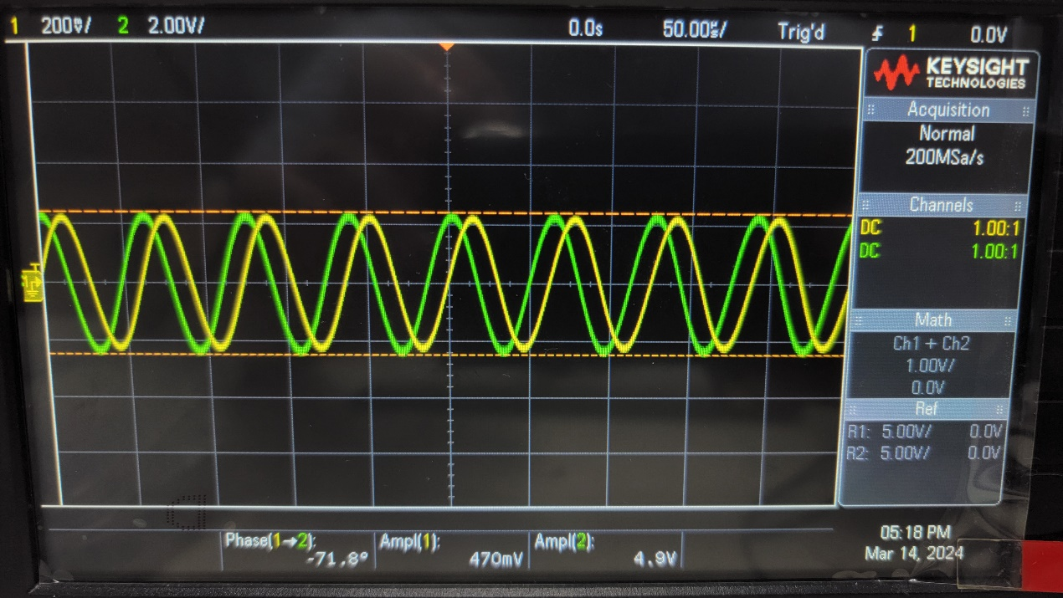

▲ Figure 9. Results of Experiment 3.b.3

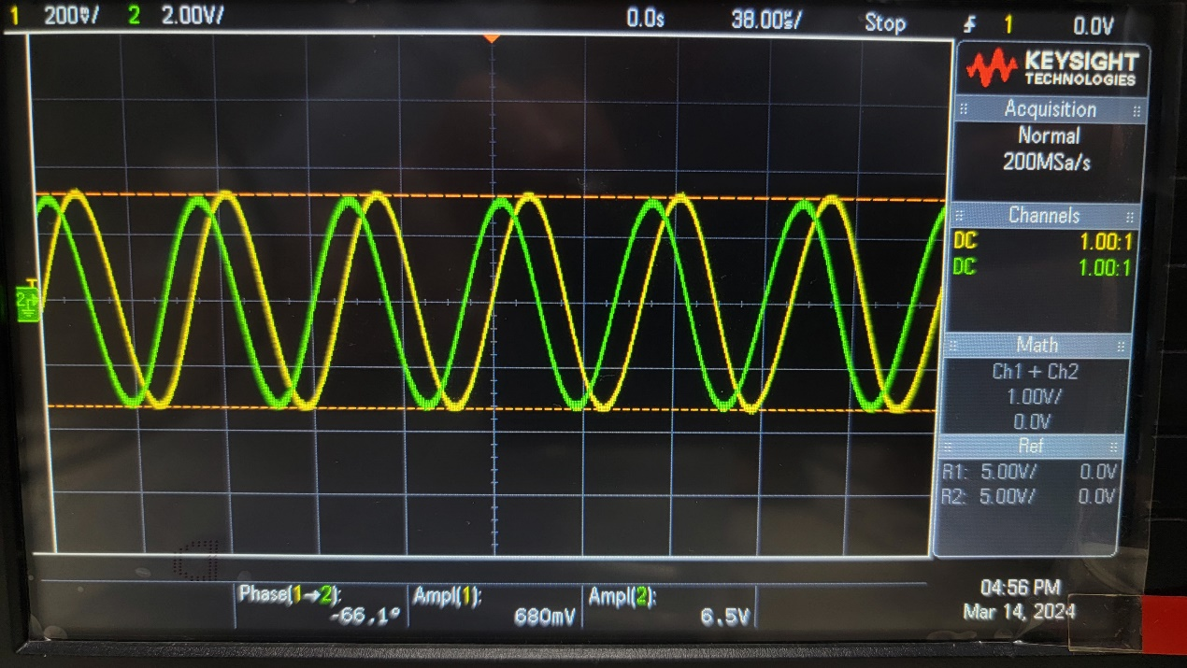

▲ Figure 10. Results of Experiment 3.c.2

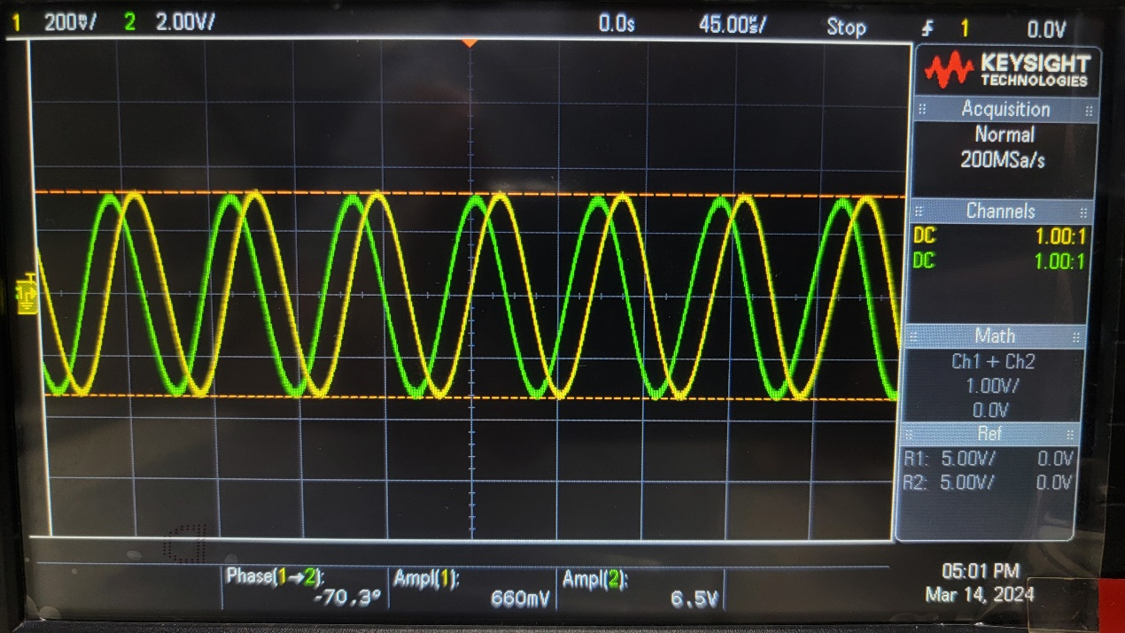

▲ Figure 11. Results of Experiment 3.c.3

1. Discussion

Explain why the phase lag between current and voltage for the inductor is not 90°?

Because of the impedance and resistance involved, the phase lag will not be exact 90°. But the higher the frequency is, the phase lag will be more close to 90°.

1. Conclusion

From the graphs above, current will lag voltage.